Third Party Posting Requirements Document

Votecal is designed to allow government agencies and non-governmental organizations (Posting Entities)to post pre-defined data to the redesigned California Online Voter Registration application (COVR) so that the users who visit the Posting Entity’s site can begin the voter registration application process on the Posting Entity’s site and complete the process on the Secretary of State’s COVR website application without re-entering the pre-approved data on the Secretary of State (SOS) COVR website application.

To authorize a Posting Entity, the SOS will enter into a Memorandum of Agreement (MOA) with each Posting Entity, which authorizes the Posting Entity to post data to the COVR application page on condition that Posting Entity to do all of the following: 1) meet certain security requirements; 2) make certain disclosures to its users; and 3) meet certain data standardization requirements.

This document defines the security and data standardization requirements for posting the data to the COVR website application for the completion of the voter registration application process for eligible California residents.

- Accessibility
The Posting Entity must comply with the following:
At a minimum, conform to accessibility standards cited in California Government Code section 11135, Section 508 of the United States Rehabilitation Act, and the Web Content Accessibility Guidelines 2.0 (W3C World Wide Web Consortium Recommendation WCAG 2.0 12/2008, Level A & Level AA Success Criteria) (Guidelines). The Guidelines help assist organizations in making web content more accessible for people with disabilities.

- Security Requirements
The Posting Entity must do all of the following:
- Submit the IP source addresses of the server hosts, which will be communicating with COVR and from which posts will occur, at least thirty (30) days in advance of expected use. Posts will be restricted to authorized IP source addresses.
- Implement a COVR API Key. This is a unique key issued to the Posting Entity which identifies the Posting Entity with each communication with COVR. The COVR API Key will be a parameter within every Pre-Save Operation and HTTP Post communication (see details in Section 6). This will be a random key, which will be generated by the SOS and issued to a Posting Entity for a period of time and which may expire upon termination of this agreement. This key will be used to identify the Posting Entity and will be validated with each communication. Upon successful validation by the SOS, the Posting Entity will be allowed to post the data to COVR. If the key is invalid, access to COVR will be denied.

- Disclosure Requirements
The Posting Entity must comply with all of the following:
- Provide all of the disclosures below, and any additional disclosures the SOS may hereafter require, to each applicant who may enter information on the Posting Entity’s website for posting to COVR:
  - “Safe at Home”
  - “Registration Deadline”
  - “What You Will Need”
  - “Additional Information”
  - “Have Questions or Want to Report Fraud?”
- Implement an appropriate method for retrieving from the COVR website and immediately displaying for each applicant the up-to-date official wording for the above disclosures. The SOS may modify the official wording of the disclosures at any time. Up-to-date official wording for the above disclosures will be found on the COVR website in the following languages: English, Spanish, Chinese, Hindi, Japanese, Khmer, Korean, Tagalog, Thai and Vietnamese.

- Request each applicant to confirm that he or she has read and acknowledged the above disclosures.
- Transmit confirmation to the SOS that each applicant has read and acknowledged the above disclosures.

See Appendix A for details on the method for transmitting confirmation that an applicant has read and acknowledged the above disclosures and the current official wording of the disclosures.

- Privacy Requirements
The Posting Entity must comply with all of the following:
- Conform to industry standards for website privacy and security.

- Subject to the restrictions provided in Elections Code Section 2914 (a)(2), obtain prior affirmative, express consent from each applicant for any use or sharing of applicant information for any purpose other than posting to COVR. For example, prior affirmative, express consent must be obtained for use of applicant information for political purposes, such as following up to encourage the applicant to vote on Election Day.

- Enable an applicant to proceed immediately to COVR to complete and submit a voter registration application, if the applicant declines consent under paragraph (b) above.

- Never request, capture, or store a California driver license number, California identification card number, or social security number from any voter registration applicant for any purpose.

- Ensure that neither the Posting Entity nor its subcontractors surreptitiously captures, stores, misuses, sells, leases, loans, or delivers possession to a third party of any applicant information provided for the purpose of posting to COVR.

- Data Collection Requirements for COVR Post
The Posting Entity must comply with all of the following:
- Ask each applicant to choose a language to complete the COVR voter registration application and transmit the processing language parameter value to the SOS. (e.g., “Language = en_US”). See Appendix B for a list of languages and language codes.

- Collect and post only to the fields below designed to permit a Post:
    - I am a US citizen.
    - I will be 18 or older by the next election.
    - Prefix (Mr./Mrs./Miss/Ms.)
    - Legal Name (First/Middle/Last)
    - Email
    - Phone Number
    - Date of Birth (MM/DD/YYYY)
    - Place of Birth: U.S. State/Territory or Foreign Country/Region
    - Ethnicity/Race
    - Language Preference for Election Materials
    - Home Address (Street address, Apartment or unit number, City, State, Zip)
    - Mailing Address (Street address or P.O. Box, Apartment or unit number, City, State, Zip)
    - Non USPS Address – No home address (Description of where you live, county)
    - Previous Registration (Legal Name, Street address, Apartment or unit number, City, State, Zip)

- Provide at least thirty (30) days prior notice to the SOS of which of the fields above will be included in the Posting Entity’s Post.

See Appendix C for a list of detailed requirements for each field.

Posting Agency Service
Posting Agency Pre-fill implementation consist of two methods, a) Data Pre-Save Operation to save the posting data after primary validation and in, b) Https Post method to retrieve the pre-save data and pre-fill the form for the user on redirected page.
- Data Pre-Save Operation.
Posting Agency data pre-save operation hosted by SOS on S as WCF service will help the posting agency to pre-save all allowed posting data to COVR temporary table and get a record identifier (PostingAgencyRecordId) for the pre-saved record.
The pre-save data operation will perform a primary validation on posting data and return status as failed with error if validation is not successful, otherwise if validated without error then the status will be successful and PostingAgencyRecordId will be returned so that Posting agency can make the HTTPs Post call with PostingAgencyRecordId. The client details for this service will be issued by SOS to authorized Posting Agency along with Posting Agency Key which is unique for agency.

- HTTP Post with record identifier
Once the Posting agency receives a successful status for the Data Pre-Save Operation along with a PostingAgencyRecordId, Posting agency can make the HTTPs Post call which contain only few parameters as follows. (Given domain may change in testing/production).
https://covr.sos.ca.gov/?language=en_US&t=p
{ CovrAgencyKey=d2DE1Nht8I
PostingAgencyRecordId = 999999}
Upon receiving the HTTPs post call with record id and Agency key, COVR application will retrieve the Pre-saved data and pre-fill the voter registration application page.

COVR Posting Agency Diagram
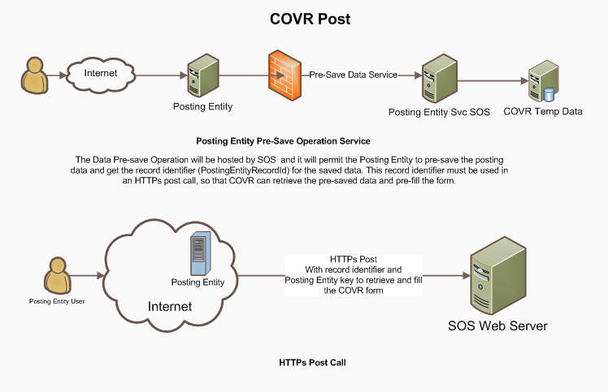
Pre-Save Service and HTTPs Post

Appendix A
Disclosures Requirements

A boolean parameter must be passed to the SOS, which confirms that each applicant has read and acknowledged the below disclosures.

Safe at Home Participants
Please do NOT use this form to register or re-register to vote if you are enrolled in a confidential address program such as Safe at Home. If sharing your address could put you in life-threatening danger, you may be eligible to register to vote confidentially.
For more information, contact the Safe at Home program at (877) 322-5227 or visit www.sos.ca.gov/safeathome/.
Registration Deadline
The deadline to register or re-register to vote for any election is 11:59:59 p.m. Pacific Time on the 15th calendar day before that election.

If this deadline has passed:
- You can submit an application and it will be processed for future elections.
- You have the opportunity to “conditionally” register to vote and vote provisionally at your local [county elections office]*. Contact your local county elections official for more information or visit [Conditional Voter Registration]*.

*county elections office link: http://www.sos.ca.gov/elections/voting-resources/county-elections-offices/
**Conditional Voter Registration link: http://www.sos.ca.gov/elections/voter-registration/conditional-voter-reg/

What You Will Need
To register online you will need
- Your California driver license or California identification card number;
- The last four digits of your social security number; and
- Your date of birth.
Your information will be provided to the California Department of Motor Vehicles (DMV) to retrieve a copy of your DMV signature.
If you do not have a California driver license or California identification card, you can still use this form to apply to register to vote by completing the online interview by 11:59:59 p.m. Pacific Time on the 15th calendar day before an election.

Additional Information
For more information on registering to vote you may want to visit the Secretary of State's Frequently Asked Questions.

Have Questions or Want to Report Fraud?
Call the Secretary of State's Voter Hotline at (800) 345-VOTE (8683) or your county elections office. Appendix B

Appendix B

List of Processing Languages
Description | LanguageCode
English | en_US
Chinese | zh_CN
Vietnamese | vi_VN
Korean | ko_KR
Tagalog | tl_PH
Japanese | ja_JP
Hindi | hi_IN
Khmer | km_KH
Thai | th_TH
Spanish | es_MX

Appendix C
Requirements for Fields Permitting a Post
Tabs and carriage returns will also be prohibited.

Email Confirmation

If the Posting Entity collects an email address, then it must require an applicant to enter his or her email address, and then re-enter his or her email address. The email addresses entered must be identical.

Field Description, Parameter, Type, Possible Values/Constraints
Please see VoteCal’s Posting Entity Interface Service validations business rules document.

However, the creation of post functionality for the Federal Post Card Application (FPCA) portion of the COVR application for military and overseas voters (UOCAVA voters) is not within the scope of COVR .

